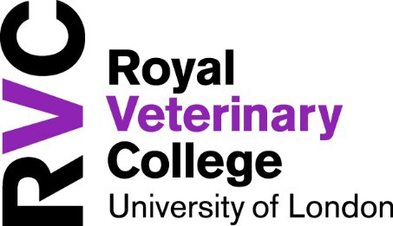

Dignity at Work and Study Ambassadors

Dignity at Work and Study Ambassadors are members of staff from different parts of RVC. They have been trained to offer informal support and information to anyone at work who feels they have been inappropriately treated, bullied, or harassed, whether this is by a peer, someone junior to them, or someone senior to them.
Refer to the Dignity at Work and Study Policy for further information which is available on the RVC intranet. Alternatively, you can contact the Head of Equality, Diversity and Inclusion, Ferhat Nazir-Bhatti: fnazirbhattit@rvc.ac.uk.

Name | Contact Details | Department/Campus
Nicola Read | nread@rvc.ac.uk | CSS/Hawkshead
Sally Burton | sburton@rvc.ac.uk | PSD/Hawkshead
Karen Humm | khumm@rvc.ac.uk | CSS/Hawkshead
Holly Smith | hssmith@rvc.ac.uk | CSS/Hawkshead
Jackie Cardwell | jcardwell@rvc.ac.uk | PPS/Hawkshead
Daniel Ngugi | dngugi@rvc.ac.uk | PPS/Hawkshead
Natalie Hubble | nhubble@rvc.ac.uk | PSD/Hawkshead
Caroline Pellet-Many | cpelletmany@rvc.ac.uk | CBS/Camden
Tom Moody | tmoody@rvc.ac.uk | PSD/Camden
Rebecca Wombwell | rwombwell@rvc.ac.uk | PSD/Camden
Rebecca Geddes | rgeddes@rvc.ac.uk | CSS/Hawkshead
Serena Maini | smaini@rvc.ac.uk | CSS/Hawkshead

