This bursary is made possible by a generous legacy donation from Ted Nelson.
The Fund offers BVetMed students in their 3rd, 4th and 5th years experiencing financial difficulty, a £250 bursary towards potentially career-informing EMS Farm placement opportunities in the UK or abroad.
Deadline: Friday 28th February 2025
Please ensure you meet all the criteria below before applying to the fund:
- RVC Enrolled UK, EU or International student
- Accessing all loans and grants you are entitled to from your respective government (i.e. SFE, SFW, SFNI, SAAS, US Federal Loans, Canadian Loans etc.)
- Years 3, 4 or 5 BVetMed/BVSc
- Need financial support to attend a farm placement between March - September 2025
- Must provide a short report on your placement if your application is successful
Name

Student number

Term Time Address
Email address

Placement Name and Address
Proposed date of placement (please estimate if not yet confirmed)
Length of placement in weeks

Has your placement already been approved by the Placements Team? YES/NO

If so, please include your e-mail confirmation when submitting your application.
If not, any award made will be subject to approval.
Please answer yes or no to the following questions:
Do you live with your parents/guardians during term time:  Do you live with a partner:  Do you have any adults that are financially dependent on you:  Do you have any dependent children:  Are you a care leaver or estranged from your parents:  Are you a carer:  Have you ever been homeless or lived in a Foyer: |  | Yes/No  Yes/No  Yes/No  Yes/No  Yes/No  Yes/No  Yes/No

Income and Expenditure

Please complete the sections that are relevant to your circumstances. Information on the supporting documents needed can be found on the final page of this application form.

Income:
Type | How much? | How often?
UK students
Tuition Fee Loan | £ | Annual
UK Students: Maintenance Loan | £ | Annual
EU/International/Second Degree Students
Other Income: Tuition Fees | £ | Weekly/Monthly/Annual
Other Income: Living Costs | £ | Weekly/Monthly/Annual
Students with Partners and/or Children
Partners Income/Earnings (After Tax) | £ | Weekly/Monthly/Annual
Child Benefit | £ | Weekly/Monthly/Annual
Other Benefits | £ | Weekly/Monthly/Annual
Partner Support | £ | Weekly/Monthly/Annual
All Students
Parent / Family Support | £ | Weekly/Monthly/Annual
Other Income | £ | Weekly/Monthly/Annual

Expenditure:
Type | How much? | How often? (Delete as appropriate)
Rent/Mortgage | £ | Weekly/Monthly/Annual
Travel Costs: Public Transport/Car | £ | Weekly/Monthly/Annual
Council Tax (if applicable) | £ | Weekly/Monthly/Annual
Childcare Costs | £ | Weekly/Monthly/Annual
Any other essential expenditure | £  £ | Weekly/Monthly/Annual  Weekly/Monthly/Annual
Supporting Statement
1. Please describe the placement opportunity and how it fits with your personal aspirations? What will you gain and why will it be important for your future career? (min 250 words)

2. How much funding do you need to attend the placement?
Travel £
Accommodation £
Other Costs £
Would an award be necessary for you to be able to participate in this placement? If the cost of the placement is greater than the award made, how do you plan to cover the shortfall? Please give details of any costs already secured:

You may also use this space to explain or clarify, if you wish, any income or expenditure detailed above:

DECLARATION:
- I declare that the information given above is correct and complete to the best of my knowledge.
- I confirm that if I receive an award, I will provide feedback to the RVC and ACT on how the funding helped me during my studies in a timely manner. I understand failure to provide this feedback may result in the award being withdrawn.
- I understand that giving false information will disqualify my application and may also lead to disciplinary procedures.
- I undertake to repay any assistance given to me should the information I have provided prove to be false.
- I accept that the decision of the RVC panel is final.
- Submission of this application is evidence that I accept and agree to the above.

Signed: Date:

BANK DETAILS:
Bank Name e.g. HSBC, Natwest
Sort Code
Account Number

ANY AWARD MADE WILL BE PAID VIA BACS TO THE ABOVE ACCOUNT

Confidentiality

Your application will be stored securely within Advice Centre student files which are not accessible to staff outside of the Advice Centre.

In order for payments to be made, your name, student number and bank details submitted on this form will be shared with RVC Finance department staff who may contact you to clarify bank account information.

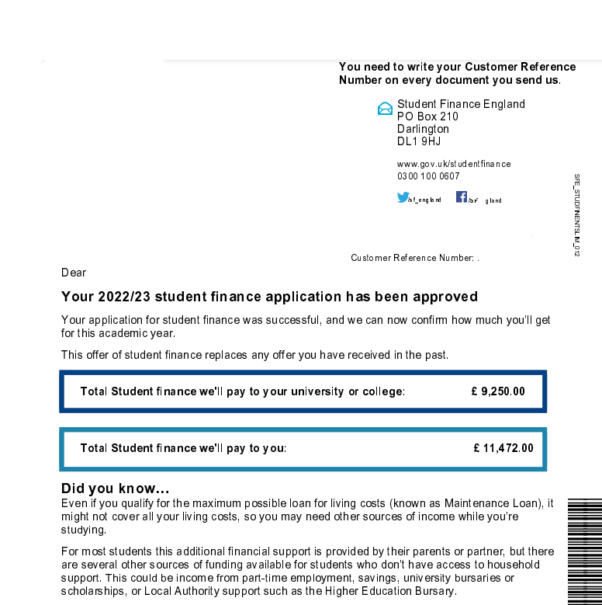
Evidence required:
Please provide copies of documents from the list below as applicable to your circumstances. If you do not supply the relevant evidence we will not be able to assess your application.

Income: All Students
☐ Student Finance Entitlement Summary 2024/25
Log in to your online account, select ‘Undergraduate Applications’ then ‘2024/25 application’ and then ‘Your Inbox’ at the top of the screen. You should then be able to find your entitlement summary letter for the 2024/25 academic year. Examples of page 1 and 3 of the letters can be seen left and below:
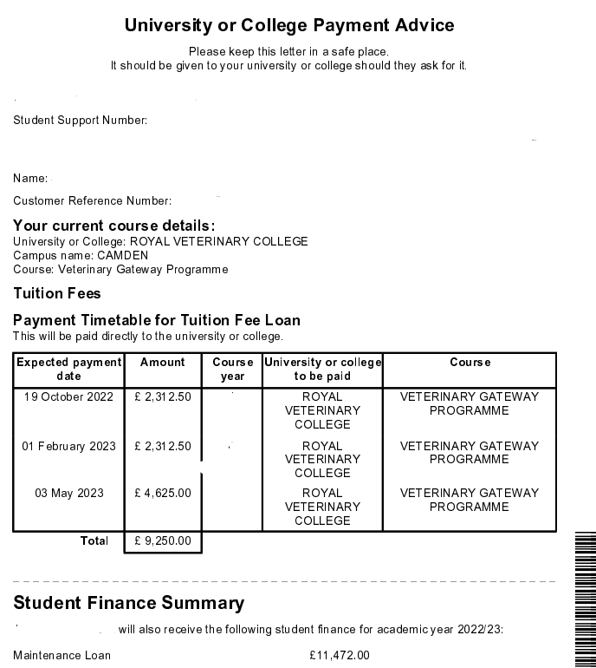
☐ Confirmation of any other funding e.g. loans, scholarships, grants, etc (where applicable).

Expenditure: All Students
☐ Evidence of rent/mortgage: Your current tenancy agreement or most recent mortgage statement, with your name, the address of the property and showing how much rent/mortgage you pay per month.

☐ Bank Statements: Your statements must include your full name, address, starting and closing balance, any other named account holder, and last 4 digits of the account number.
Upload two months bank statements for all your accounts including savings and joint accounts. The statements must cover the last two months up to the date you submit your application (or within two weeks of the date you submit your application).
Please include explanations for all income and spending over £99.
If you can't add this information to your bank statements directly, please include a separate word document explaining any transactions over £99 e.g., student loan, wages, money from parents.
If you bank online, you should be able to download your bank statements from your online account. If you are unsure how to access your bank statements, please visit your banks' website for step-by-step guidance.

☐ Council Tax Bill (where applicable)

Students who live with a partner and/or dependent children:
☐ Proof of partner’s income (where applicable) e.g. recent benefits letter, 2 months wage slips
☐ Bank statements for two months for joint accounts
☐ Child Benefit Letter or Children’s Birth Certificates if they are living with you
☐ Evidence of benefits claimed including Tax Credits or Universal Credit (where applicable)

