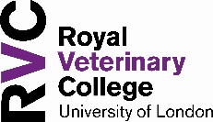

Animal Academy - Reflection
The Royal Veterinary College

Use this document to write down notes about what you have learnt from the Animal Academy webpages. These will help you structure things like a personal statement, and help you think about your goals
New words I have learnt
New knowledge or skills I have gained
What I was most interested in
Now, reflect on one new clinical skill or scientific term you have come across on the Animal Academy webpage;

The term
What does it mean?
When might it be used in careers with animals?

Finally, what are your next steps to achieving your goal?

My goal
Do I need any particular A-levels or BTecs to do that? | You might want to look at entry requirements at the RVC here
Do I need a degree to do that? If so, where offers the right degree? | You might want to look at UCAS here
Do I need to do work experience? If so, how much? | You might want to look at this comprehensive guide to vet schools here
What do I like about this goal? Are there other things I might also enjoy? | E.g. I like that I get to work with animals, what other jobs are there with animals?

